SmartWilds Heatmap Analysis Report
Multi-Modality Species Monitoring at The Wilds

Executive Summary
This report presents a detailed analysis of species detection data collected using three different monitoring methods: drone aerial surveys, bioacoustic audio recordings, and camera trap photographs. The data was collected at The Wilds during August 2025.
We created eight different heatmap visualizations to help understand when and where animals are most active. These visualizations use colors to show patterns in data - darker colors mean more animal detections, and lighter colors mean fewer detections.
Key Findings at a Glance:
- 85,822 total bird detections from bioacoustic recordings across 25 days
- 18,094 deer detections from drone footage in just 6 minutes of flight
- 3,627 camera trap detections from 1,370 unique photographs
- Dawn is more active than dusk for bird vocalizations
- Deer peak activity at 5-6 PM (crepuscular behavior confirmed)

1. Understanding the Data Sources
We collected data using three different methods. Each method captures different types of information and works best for different animals.
Method | What It Captures | Best For | Time Period
Drone Video | Aerial video of animals from above | Counting large herds in open areas | July 1, 2025 (6 minutes)
Bioacoustic | Bird songs and calls from audio recordings | Identifying bird species by sound | Aug 4-28, 2025 (25 days)
Camera Trap | Photos triggered by animal movement | Photographing shy or nocturnal animals | Aug 11 - Sep 7, 2025

2. Drone Video Analysis

2.1 Drone Detection Heatmap

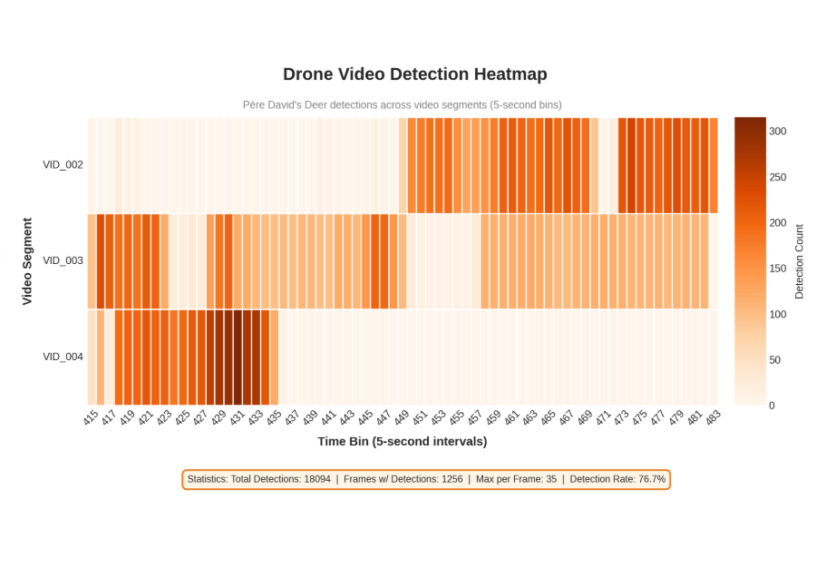
This heatmap shows how many Père David's Deer were detected in each video segment over time. The drone flew for about 6 minutes and recorded 5 separate video clips.
How to Read This Heatmap:
- Y-axis (vertical): Each row is a different video segment (VID_001 through VID_005)
- X-axis (horizontal): Time divided into 5-second intervals (bins)
- Color intensity: Darker orange = more deer visible in that moment
Statistics:
Total Deer Detected | 18,094
Total Video Frames | 1,637
Frames with Detections | 1,256 (76.7%)
Maximum Deer in One Frame | 35

Key Insights:
- VID_004 shows the darkest bands, meaning the drone flew over the most concentrated group of deer during this segment (up to 35 deer visible at once).
- VID_003 has the highest total count (7,522 detections) because it covered a larger area with dispersed deer over a longer time.
- The 76.7% detection rate shows that drones are very effective for counting animals in open habitats.
- Père David's Deer is an endangered species native to China, and The Wilds has a conservation breeding program for them.

3. Bioacoustic (Bird Audio) Analysis
Bioacoustic monitoring uses microphones to record bird songs and calls. A computer program called BirdNET analyzes the recordings and identifies which bird species are singing. We had two types of recordings:
- Sunrise/Sunset recordings: Longer recordings at dawn and dusk when birds are most vocal
- Every Hour recordings: 5-minute recordings every hour throughout the day and night
Metric | Sunrise/Sunset | Every Hour
Total Recordings | 534 | 1,036
Bird Detections | 33,012 | 52,810
Locations | TW05, TW08 | TW06, TW08
Top Species | Mourning Dove | Grasshopper Sparrow

3.1 Sunrise/Sunset Species × Hour Heatmap
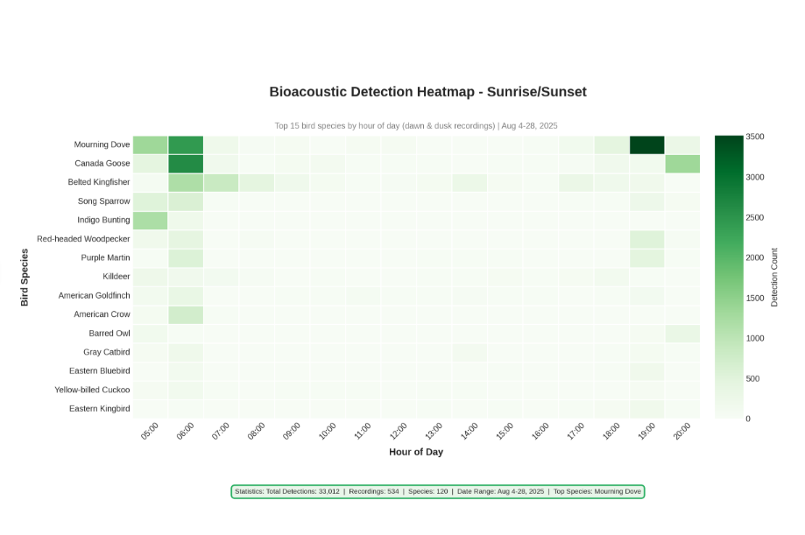How to Read This Heatmap:
- Y-axis (vertical): Top 15 bird species, sorted by total detections
- X-axis (horizontal): Hour of day when recordings were made
- Color intensity: Darker green = more bird calls detected

Top 5 Species Detected:
- Mourning Dove: 8,682 detections - The most common bird, known for its soft cooing sound
- Canada Goose: 5,318 detections - Large waterfowl with distinctive honking calls
- Belted Kingfisher: 4,101 detections - A fish-eating bird with a rattling call
- Song Sparrow: 1,532 detections - A small songbird with a melodic song
- Indigo Bunting: 1,408 detections - A bright blue songbird

3.2 Dawn vs Dusk Comparison Heatmap
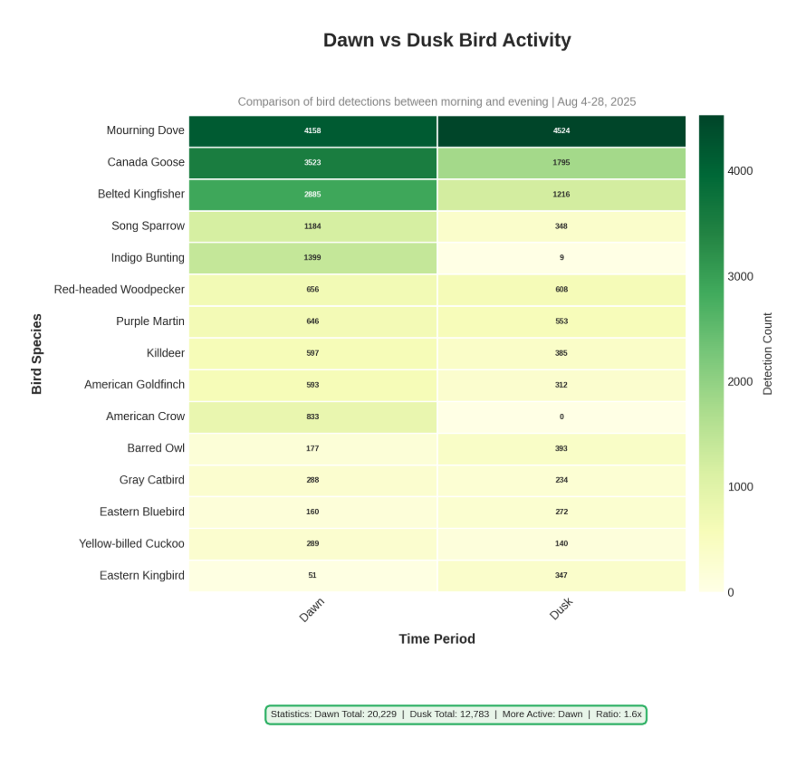This simple but powerful heatmap compares bird activity between morning (dawn) and evening (dusk). It answers the question: When are birds more vocal?
How to Read This Heatmap:
- Y-axis: Bird species names
- X-axis: Two columns - Dawn (before noon) and Dusk (after noon)
- Numbers in cells: Exact count of detections for each species at each time
Key Finding:
Dawn is significantly more active than Dusk. This is because birds use songs to establish territory and attract mates, and the calm morning air carries sound better than evening air which is often disturbed by wind.

3.3 Every Hour Species × Hour Heatmap (24-Hour Pattern)
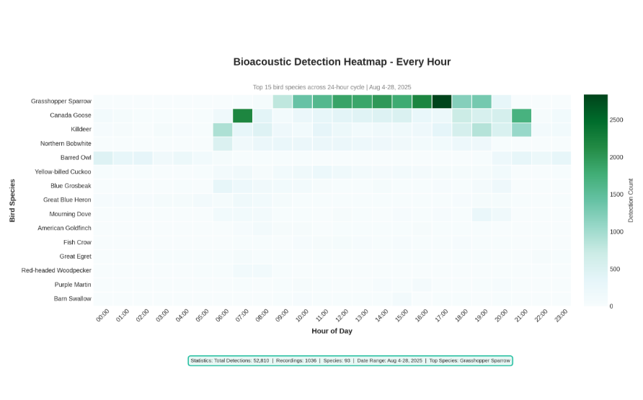This heatmap shows bird activity patterns across a full 24-hour cycle. Unlike the Sunrise/Sunset recordings, these recordings capture the complete day including nighttime.
How to Read This Heatmap:
- Y-axis: Top 15 bird species from the Every Hour recordings
- X-axis: Every hour from 00:00 (midnight) to 23:00 (11 PM)
- Color: Blue-green color scheme (darker = more detections)
Interesting Observations:
- Grasshopper Sparrow dominates: 19,294 detections - This grassland bird sings frequently during the day
- Barred Owl visible at night: 2,922 detections - You can see activity in the dark nighttime hours (their famous "Who cooks for you?" call)
- Northern Bobwhite active in morning: 3,055 detections - This quail calls "Bob-WHITE!" mostly in early morning

3.4 Hour × Day Activity Pattern Heatmap
File: bioacoustic_hour_day_heatmap.png
This heatmap shows when birds are most active across both hours of the day AND days of the month. It helps identify patterns that repeat daily and any unusual days.
How to Read This Heatmap:
- Y-axis: Hour of day (00:00 to 23:00)
- X-axis: Each column is a different day (Aug 04, Aug 05, etc.)
- Pattern to look for: Horizontal bands of color show consistent daily patterns
What This Tells Us:
- Early morning hours (5-8 AM) consistently show the highest activity across all days
- Midday hours (11 AM - 2 PM) show reduced activity as birds rest during the hottest part of the day
- The pattern is remarkably consistent, showing birds follow reliable daily routines

3.5 Location × Hour Heatmap
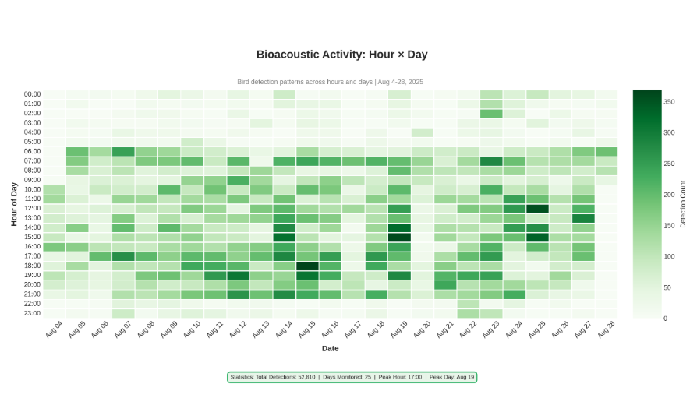This heatmap compares bird activity at different recording locations (TW06 and TW08) throughout the day.
How to Read This Heatmap:
- Y-axis: Recording location names (TW06, TW08)
- X-axis: Hour of day
- Numbers: Exact count of bird detections at each location and time

Location Comparison:
Different locations have different bird communities. This could be because of differences in habitat type (grassland vs. wetland vs. forest edge), food availability, or nesting sites.

4. Camera Trap Photo Analysis
Camera traps are motion-activated cameras that take photos when an animal walks by. The cameras were placed at three locations and ran continuously for about 4 weeks.
Total Detections | 3,627
Unique Photos | 1,370
Camera Locations | 3 (TW01_CT02, TW02_CT01, TW11_CT06)
Date Range | August 11 - September 7, 2025
Average Confidence Score | 58.9%
Peak Activity Hour | 5:00 PM (17:00)

4.1 Camera Trap Species × Hour Heatmap
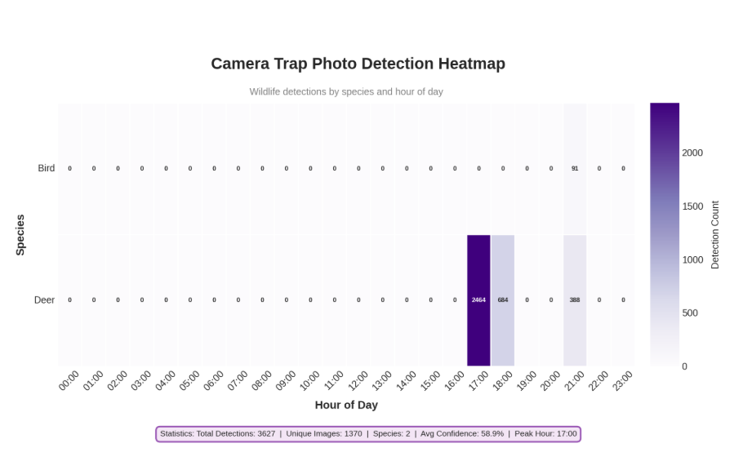This heatmap shows when different species were photographed throughout the day. The AI system (called BioCLIP) analyzed each photo to identify the species.
Key Insight - Crepuscular Behavior:
The deer show strong crepuscular behavior, meaning they are most active during twilight hours (dawn and dusk). The heatmap shows almost all deer detections happening between 5-7 PM. This is a survival strategy - deer avoid the heat of midday and also avoid being active when predators can see them clearly.

4.2 Camera Location × Hour Heatmap
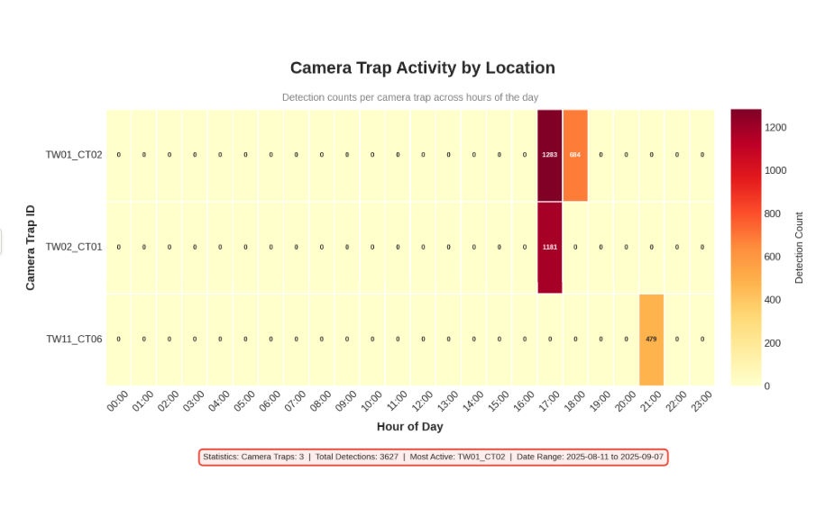This heatmap compares animal activity at each camera location throughout the day.
Camera Performance Summary:
- TW01_CT02: Best performing camera with 1,967 total detections
- TW02_CT01: 1,181 detections, mostly concentrated in a single hour (5 PM)
- TW11_CT06: 479 detections, evening-only activity (around 9 PM)

5. Summary
This analysis of multi-modality species monitoring data from The Wilds demonstrates the power of combining different detection methods to understand wildlife activity patterns.
The drone surveys proved highly effective for counting Père David's Deer in open habitats, achieving a 76.7% detection rate and capturing over 18,000 individual detections in just 6 minutes of flight time.
Bioacoustic monitoring revealed rich bird biodiversity with over 100 species detected across 85,822 total detections. The data clearly shows that dawn is the most active period for bird vocalizations, with species like Grasshopper Sparrow (19,294 detections) and Mourning Dove (8,682 detections) dominating the recordings. The 24-hour monitoring also captured nocturnal species like the Barred Owl.
Camera trap data confirmed crepuscular behavior in deer populations, with peak activity occurring between 5-7 PM. The three camera locations captured 3,627 detections across 1,370 unique photographs, with TW01_CT02 being the most productive site.
Together, these eight heatmap visualizations provide a comprehensive picture of when and where wildlife is most active at The Wilds, supporting conservation management and research efforts.

